
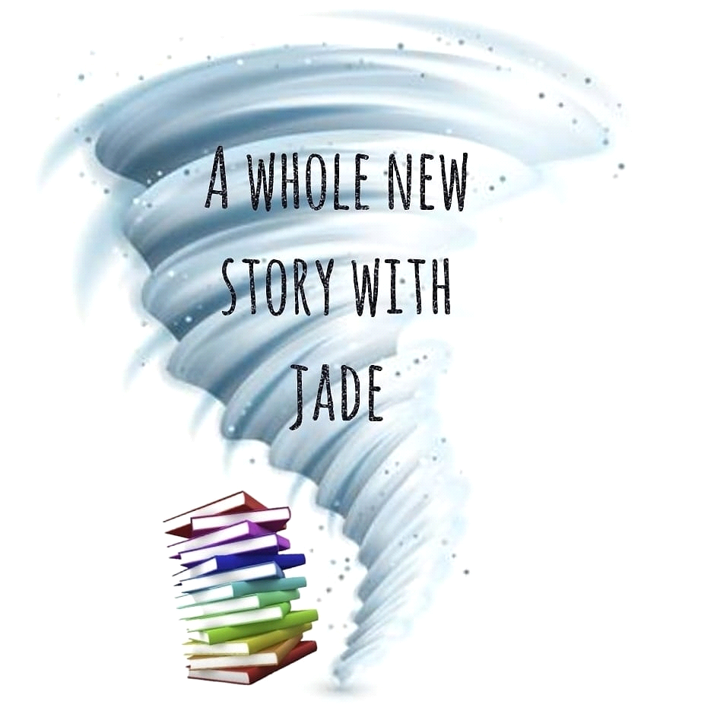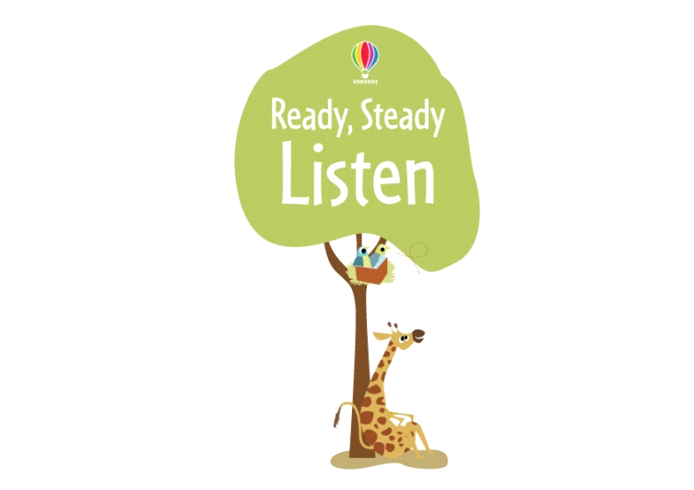

Dear Parent/Guardian,

To continue to celebrate and encourage a lifelong love of books and reading at home and school, we will be running a sponsored listen between Monday 1st March 2021 and Friday 5th March 2021.

The project is being organised in conjunction with our local Usborne Organiser, (Jade Hinton - A Whole New Story with Jade.) All the money raised will go towards brand new books for our schools.

In addition to the sponsorship money, Usborne will also donate up to 60% of the total raised in EXTRA FREE BOOKS to the school. So for every £600 raised, we will get an extra £360 in FREE Usborne books!

Please help us to enhance our reading resources for pupils in the classroom by spending a small amount of time each day reading with your child or hearing your child read. It’s not just books that you can enjoy together, comics, magazines, recipes, menus, your favourite websites - anything with words that you can read together.

If you are able to support our sponsored listen / sponsored read, please find attached a sponsorship form for your child and a listening log, to record the minutes they have spent listening or reading.

After the sponsored listen/read, please send all the sponsorship money that your child has raised to the school by Friday 12th March 2021.

Sponsor money can be sent using ParentPay.

Any contributions will be greatly appreciated and will benefit the children in school.
Thank you

